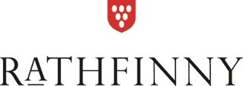

CHRISTMAS AT THE FLINT BARNS, 2018

Glass of Sparkling Wine or Mulled Wine

-

STARTER
Stilton and Broccoli Soup with Salted Sugared Walnuts
Beetroot and Seven Sisters Gin Cured Sea Trout
Crispy Coated Goats Cheese with Chilli Jam
Smoked Duck Breast with an Apple & Celeriac Salad and Spiced Pear Chutney
-

MAIN
Roast Sussex Turkey Breast with all the Trimmings
Roasted Breast of Local Pheasant Stuffed with Pork & Cherries with a Bacon, Shallot and Mushroom Sauce
Slow Braised Shin of Beef with Horseradish Dumplings
Pan Fried Bass Fillet with Crushed New Potatoes, Spinach & Watercress Sauce
Ultimate Nut Roast with Wild Mushroom Sauce

All Served with Roast Potatoes and Seasonal Vegetables

-

DESSERT
Traditional Christmas Pudding served with Brandy Butter and Cream
Black Forrest Roulade
Clementine Panacotta with Caramel Sauce
Cheese Board with Artisan Crackers and Chutney

-
Tea and Coffee with Mince Pies and Handmade Chocolates

3 COURSES £49.50

